Setting up Imaging Equipment

**Raspberry Pi**

1) Connected Vanja SD card reader to USB-C port in MacBook Pro

2) Downloaded Raspberry Pi Imager application for graphical SD card writing tool to install OS on 8GB Netac SD card

3) Selected recommended Raspberry Pi OS (32-BIT) as the working OS

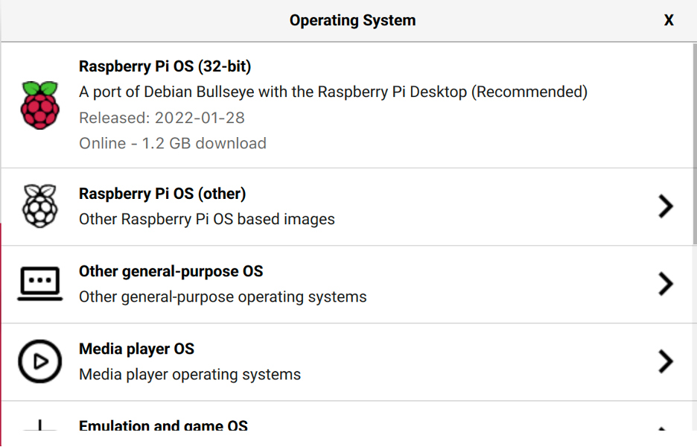

4) Selected 8GB Netac SD card as the storage device

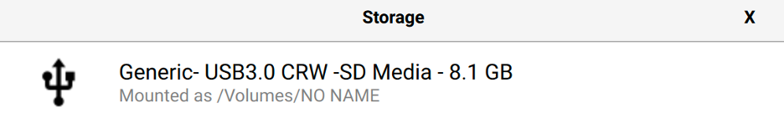

5) Wrote OS to SD card and verified SD card

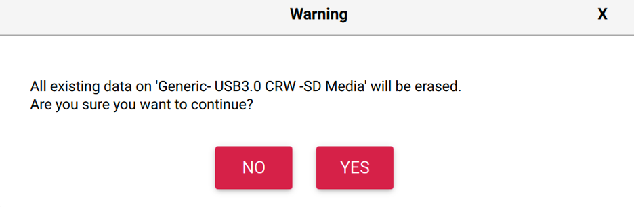

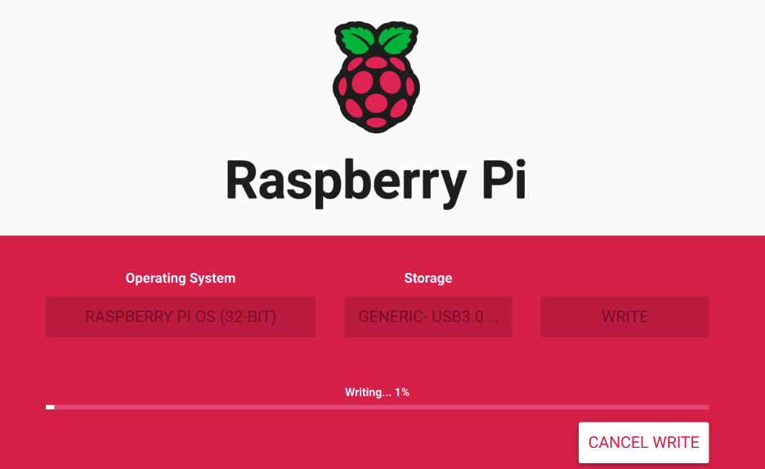

6) Ejected SD card reader external disk from USB-C port

7) Inserted SD card into interface in Raspberry Pi

8) Connected micro HDMI-HDMI cable, CSI connection cable for camera and USB-C power supply cable to Raspberry Pi

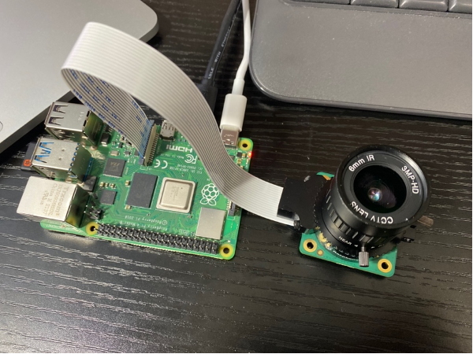

9) Ran “raspi –config” in sudo root directory to load software configuration tool as shown below

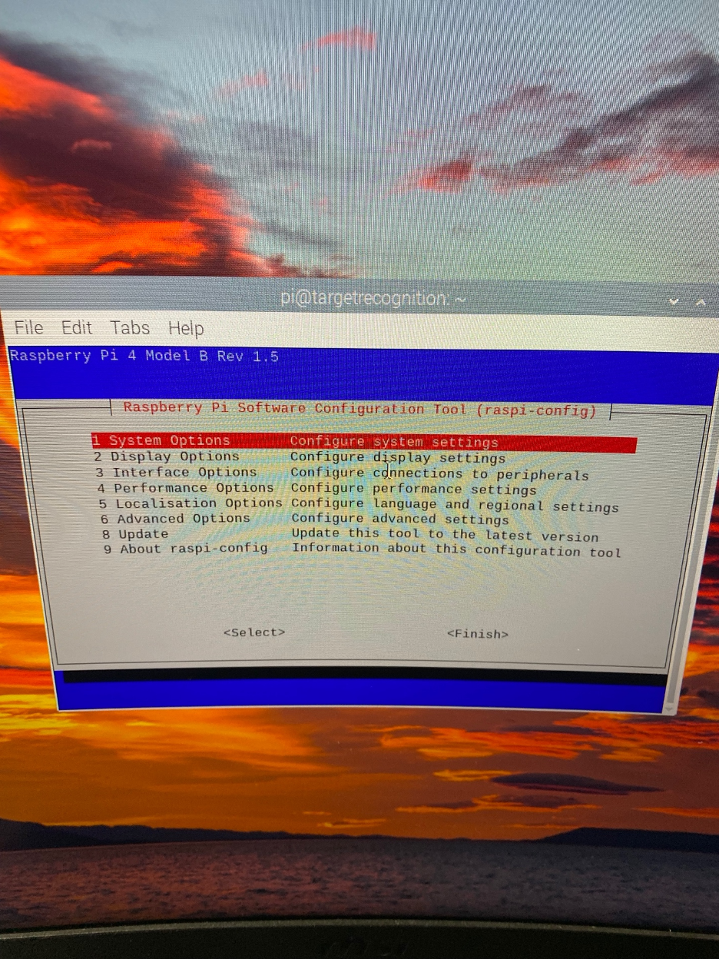

10) Under “System Options”, the login password was changed to “TargetAcquired”, the hostname and user were changed to “targetrecognition”.

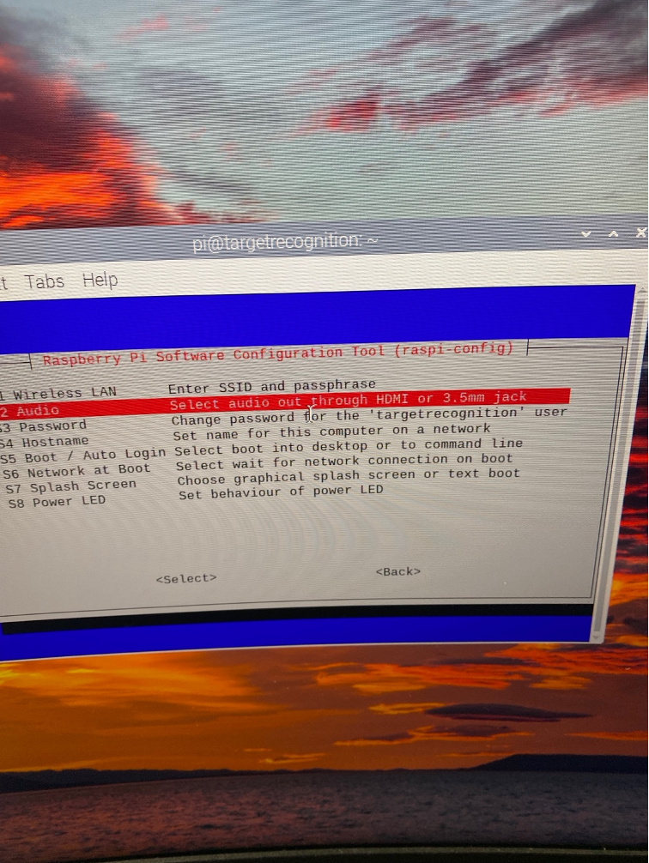

11) Under “Interface Options” “SSH” and “VNC” were enabled to permit usage of remote command line interface control and to view display headless (without cable connection) respectively.

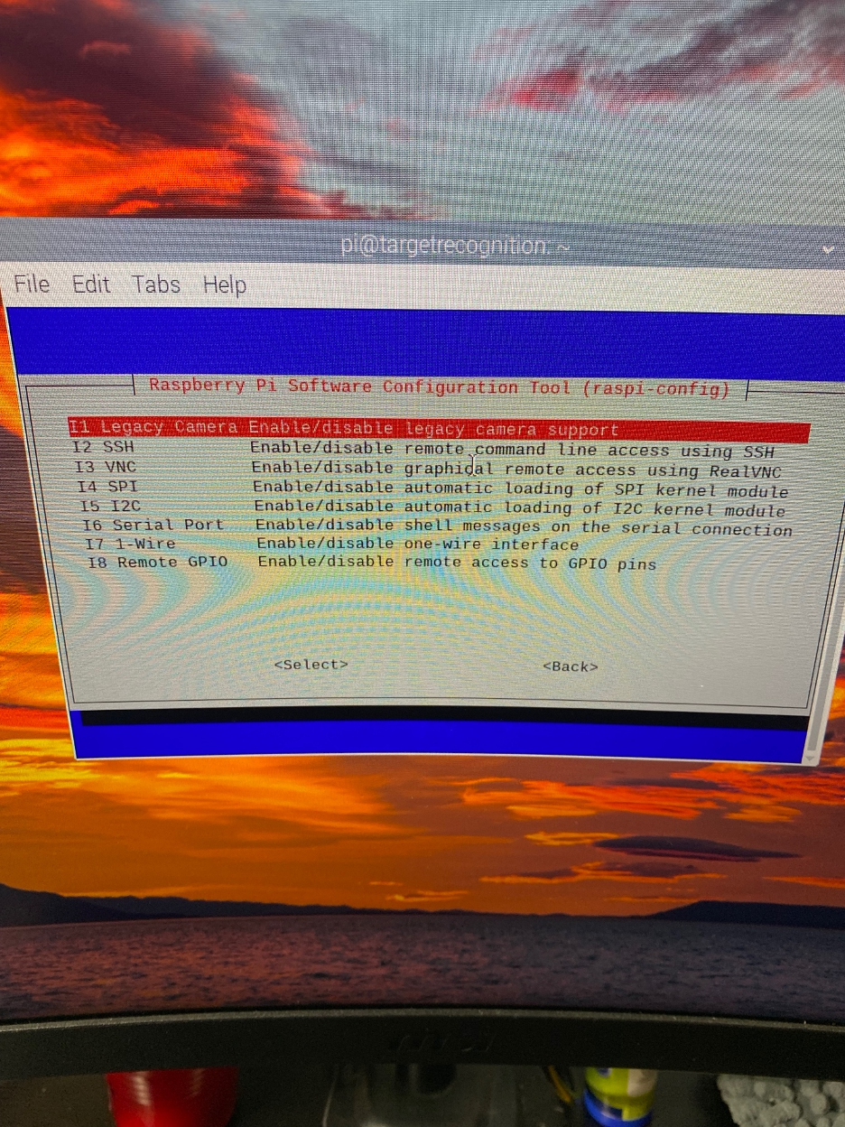

12) Downloaded “VNC Viewer” application to allow for screen casting of raspberry pi display to remote devices

13) Established connection between Raspberry Pi OS and Local Mac OS using ssh client by running “ssh pi@targetrecognition” and inputting “TargetAcquired” as the password.

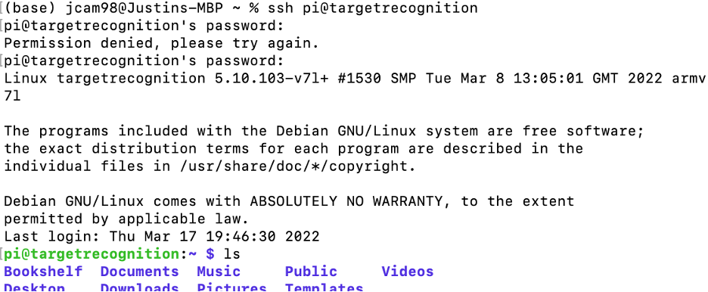

14) Ran “dig targetrecognition” to obtain information on IP address of Raspberry Pi

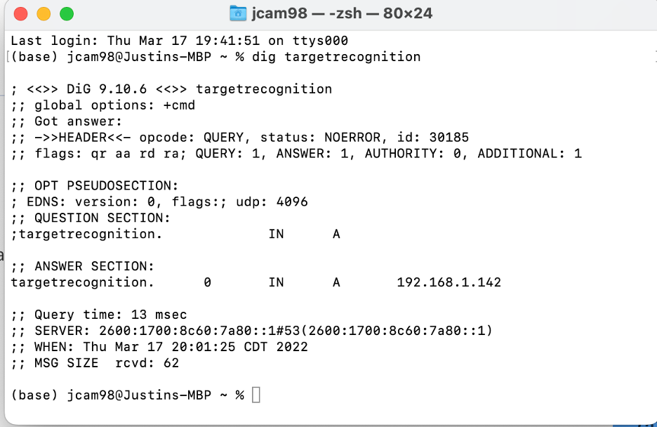

15) Inputted the IP address of Raspberry Pi device into the server address entry field in VNC Viewer app to activate the screen casting from Raspberry Pi computer to local machine (assuming both are connected to same network)

**Arducam High-Definition Camera**

1) Screwed the components that adjust the aperture and focus of the camera into the camera’s circuit board.

2) Reoriented an inverted pin on the CSI cable connector flex strip and changed orientation of entire cable so that the blue adhesive is directed away from the camera circuit board at the camera circuit board interface, and towards the USB and ethernet interfaces at the Raspberry Pi camera interface as shown in the image below.

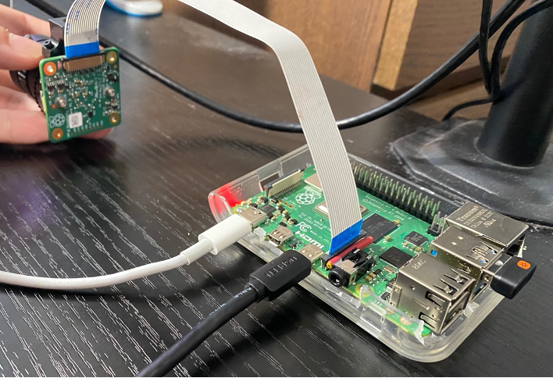

3) Tested image capture functionality of camera by running “raspistill -o image.jpeg”

and “raspistill -o image.png”

4) The following command captures an image with a resolution of 640 x 380 with a 2 second wait time, flips the image horizontally and vertically, and assigns it to a filename “image2.jpg” and stores in home Pi directory

“raspistill -t 2000 -o image2.jpg -w 640 -h 380

5) The following command captures a five second video at default resolution of 1080 p 30 and store in filename “video”

“raspivid -t 5000 -o video.h264”

6) The following command captures a video for 10 seconds at 640 x 480 resolution with a frame capture rate of 90 fps

“raspivid -w 640 -h 480 -fps 90 -t 10000 -o 90fps.h264”

7) The following command installs application that converts “h264” video file format to “mp4” format

“ sudo apt-get install gpac”

This application can be removed by running “sudo apt autoremove”

8) The following command converts the video “90fps” from a “h264” filetype to a “mp4” filetype

“MP4Box -add 90fps.h264 -fps 90 90fps.mp4”

9) The following command displays details about Raspberry Pi’s memory

“cat /proc/meminfo”

10) The following displays the size and number of partitions being used on the SD card

“cat /proc/partitions”

11) The following command displays the memory split between the CPU and GPU which can be adjusted on config screen

“vcgencmd get_mem arm && vcgencmd get_mem gpu”

12) The command below will display the available system memory

“free --giga -h”

13) The following command checks the free disk space on the Raspberry Pi

“df -h”